|  |  |
| --- | --- |
| **DOKUMENTASI EKSTERNAL**  External Documentation |  |
| **[TUGAS ~~MANDIRI~~ / PROYEK ]**  **[*Assignment / Project*]** |
| **COMP6176– Human Computer Interaction**  ***Subject*** |
| SEMESTER [~~GANJIL~~/GENAP/~~PENDEK~~] 2019/2020 ***[~~Odd~~/Even/~~Compact~~] Semester Year 2019/2020*** |

## Judul Proyek

*[Assignment / Project]**Title*

* **Rainbow Seven Siege Promotional Website**

## Abstrak [50 – 200 words]

*Abstract*

* **ABSTRACT [50 – 200 words]**

## Pendahuluan

*Introduction*

* **INTRODUCTION**

## Dokumentasi

*Report / Documentation*

* Image Slider

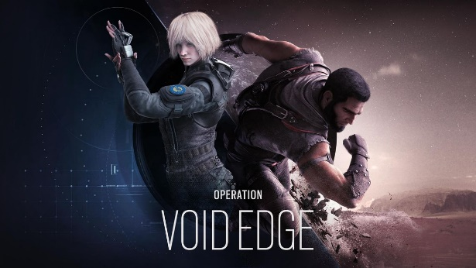

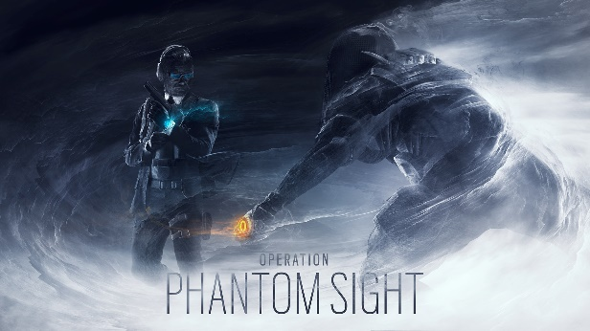

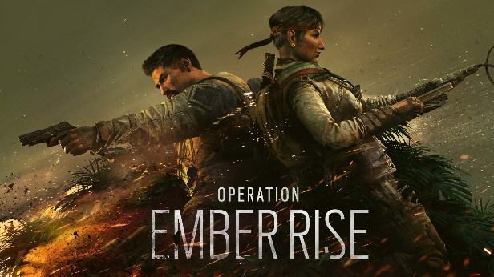

## Referensi

*References*

* **Dagger**

<div>Icons made by <a href="http://www.freepik.com/" title="Freepik">Freepik</a> from <a href="https://www.flaticon.com/" title="Flaticon">www.flaticon.com</a></div>

* **Bullet Mark**

<a href="https://www.freepik.com/free-photos-vectors/metal">Metal vector created by macrovector - www.freepik.com</a>

* **Bullets**

Icons made by <a href="https://www.flaticon.com/authors/freepik" title="Freepik">Freepik</a> from <a href="https://www.flaticon.com/" title="Flaticon">www.flaticon.com</a>

* **Bullet-2**

Icons made by <a href="https://smashicons.com/" title="Smashicons">Smashicons</a> from <a href="https://www.flaticon.com/" title="Flaticon"> www.flaticon.com</a>

* **Facebook-Logo**

Icons made by <a href="https://www.flaticon.com/authors/pixel-perfect" title="Pixel perfect">Pixel perfect</a> from <a href="https://www.flaticon.com/" title="Flaticon"> www.flaticon.com</a>

* **Twitter-logo**

Icons made by <a href="https://www.flaticon.com/authors/pixel-perfect" title="Pixel perfect">Pixel perfect</a> from <a href="https://www.flaticon.com/" title="Flaticon"> www.flaticon.com</a>

* **Instagram-logo**

Icons made by <a href="https://www.flaticon.com/authors/freepik" title="Freepik">Freepik</a> from <a href="https://www.flaticon.com/" title="Flaticon"> www.flaticon.com</a>

* **Youtube-logo**

Icons made by <a href="https://www.flaticon.com/authors/roundicons" title="Roundicons">Roundicons</a> from <a href="https://www.flaticon.com/" title="Flaticon"> www.flaticon.com</a>

* **Pistol**

Icons made by <a href="https://www.flaticon.com/authors/nhor-phai" title="Nhor Phai">Nhor Phai</a> from <a href="https://www.flaticon.com/" title="Flaticon"> www.flaticon.com</a>

* **Hamburger Menu**
* Icons made by <a href="https://www.flaticon.com/authors/freepik" title="Freepik">Freepik</a> from <a href="https://www.flaticon.com/" title="Flaticon"> www.flaticon.com</a>
* **Biohazard**

Icons made by <a href="https://www.flaticon.com/authors/smashicons" title="Smashicons">Smashicons</a> from <a href="https://www.flaticon.com/" title="Flaticon"> www.flaticon.com</a>

* **Colorpallete**

<https://coolors.co/>

* **Page Maps**

<https://www.ubisoft.com/en-us/game/rainbow-six/siege/game-info/maps>

* **Page News (Index)**

<https://www.ubisoft.com/en-us/game/rainbow-six/siege/news-updates>

<https://wallpapersden.com/rainbow-six-siege-operation-ember-rise-wallpaper/1920x1080/>

<https://www.ubisoft.com/en-us/game/rainbow-six/siege/game-info/seasons/voidedge>

<https://www.exploid.gg/rainbow-six-siege-operation-phantom-sight-kenalkan-2-operator-baru/>

* **Page Operator**

<https://www.ubisoft.com/en-us/game/rainbow-six/siege/game-info/operators>

<https://www.ubisoft.com/en-us/game/rainbow-six/siege/game-info/seasons/voidedge>

<https://www.ubisoft.com/en-us/game/rainbow-six/siege/game-info/operators/iana>

<https://www.ubisoft.com/en-us/game/rainbow-six/siege/game-info/operators/oryx>

* **Page Quarantine**

<https://rainbow6.ubisoft.com/quarantine/en-gb/>

<https://www.youtube.com/watch?time_continue=1&v=MKFPqZCfIMc&feature=emb_logo>

Disiapkan Oleh,

*Prepared by,*

* **2201731535 - Ricco**
* **<NIM> - <2nd Student Name>**
* **<NIM> - <3rd Student Name>**
* **<NIM> - <4th Student Name>**